42) приложение № 4 к Правилам дорожного движения изложить в следующей редакции:

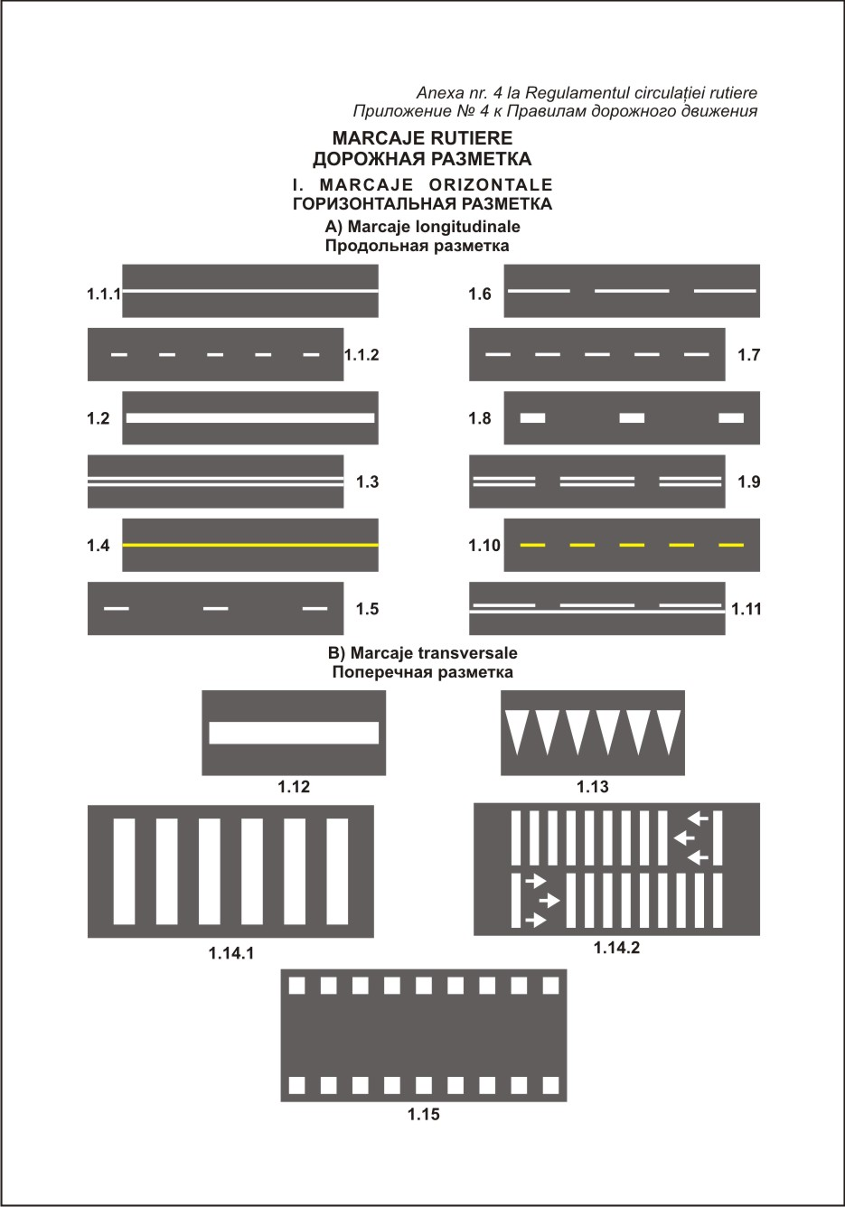

**C)Alte marcaje**

**Другая разметка**

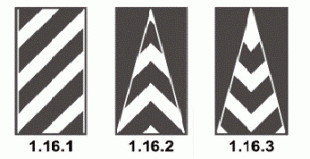

|  |  |
| --- | --- |
|  |  |
| **1.17.1** | **1.17.2** |

|  |  |  |
| --- | --- | --- |
|  | Descriere: Описание: C:\Users\Iablonskii\Desktop\sageti pre giratorii 3.jpgDescriere: Описание: C:\Users\Iablonskii\Desktop\sageti pre giratorii 1.jpgDescriere: Описание: C:\Users\Iablonskii\Desktop\sageti pre giratorii 2.jpg |  |
| **1.18.1** | **1.18.2** | **1.19** |

|  |  |  |
| --- | --- | --- |
|  |  |  |
| **1.20.1** |  |  |

|  |  |  |
| --- | --- | --- |
|  |  |  |

|  |  |  |  |  |
| --- | --- | --- | --- | --- |
|  |  |  |  |  |
| **1.27.1** | **1.27.2** | **1.27.3** | **1.27.4** | **1.27.5** |

|  |
| --- |
| **1.28** |

**II. MARCAJE VERTICALE**

**ВЕРТИКАЛЬНАЯ РАЗМЕТКА**

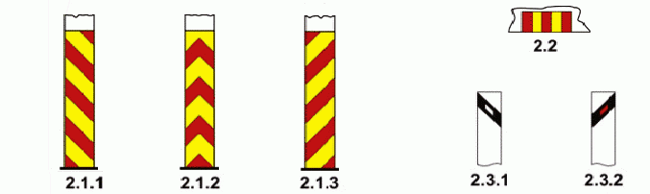 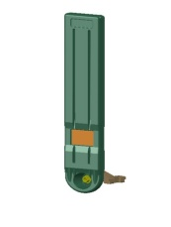 **Описание: C:\Users\Iablonskii\Desktop\indicatoare noi\paleta.jpg **

**2.4.1 2.4.2 2.4.3 2.4.4 2.5**